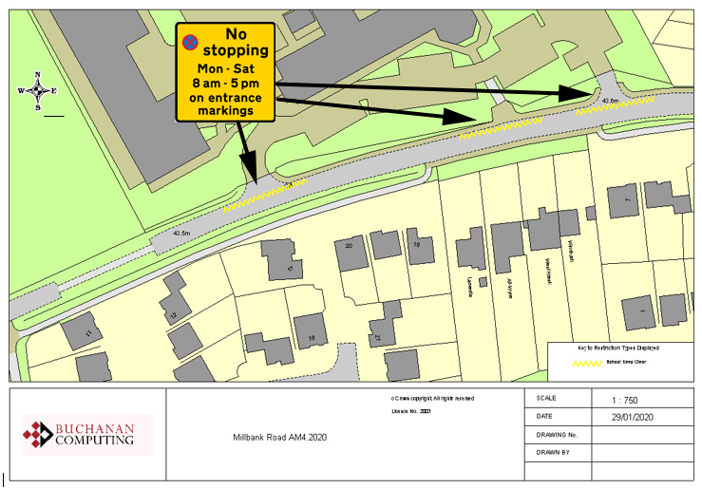



Existing school entrance markings

NB No change to restrictions as they appear on the ground
Key:
Location:
Millbank Road, Ashford
Proposed Order:

The Kent County Council (Various Roads, Borough of Ashford) (Waiting Restrictions and Street Parking Places) Amendment 4 Order 2020
Amendment 4 2020

Proposed changes

