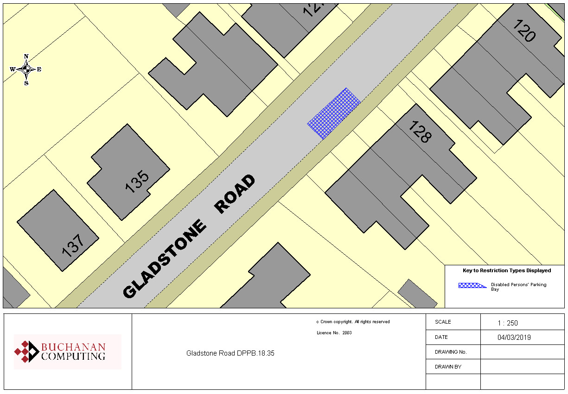

Existing disabled persons parking bay

N.B. no change to the restrictions as they appear on the ground
Key:
Location:
Gladstone Road, Ashford
Proposed Order:

The Kent County Council (Various Roads, Borough of Ashford) (Waiting Restrictions and Street Parking Places) Amendment 4 Order 2020
Amendment 4 2020

Proposed changes

