Location:
Cornes Close, Ashford
Proposed Order:

The Kent County Council (Various Roads, Borough of Ashford) (Waiting Restrictions and Street Parking Places) Amendment 4 Order 2020
Amendment 4 2020

Proposed changes

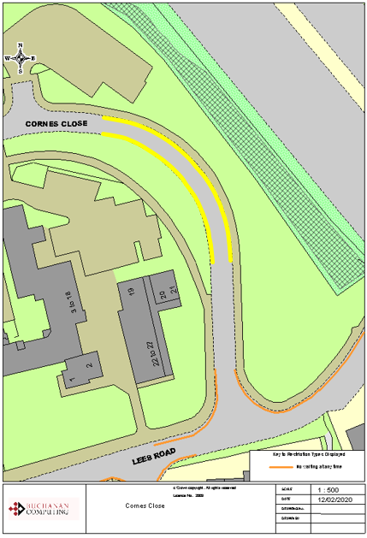
Key:

Existing no waiting at any time restrictions (Double yellow lines)

Proposed no waiting at any time restrictions
(Double yellow lines)

