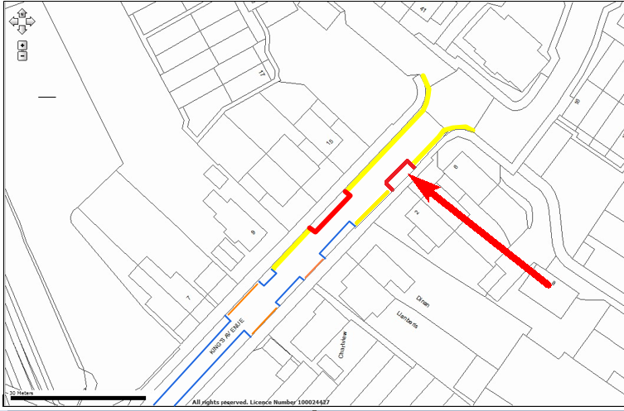
Location:
Kings Avenue, Ashford
Proposed Order:

The Kent County Council (Various Roads, Borough of Ashford) (Waiting Restrictions and Street Parking Places) Amendment 4 Order 2020
Amendment 4, 2020

Proposed changes

Key:
Amended no waiting at any time restrictions (double yellow lines)

Existing no waiting at any time restrictions (double yellow lines)

Existing shared use parking bays Permit and limited waiting
Mon-Sat 8am-10pm hours, No return to zone within 4 hours

Amended shared use parking bays Permit and limited waiting
Mon-Sat 8am-10pm hours, No return to zone within 4 hours

