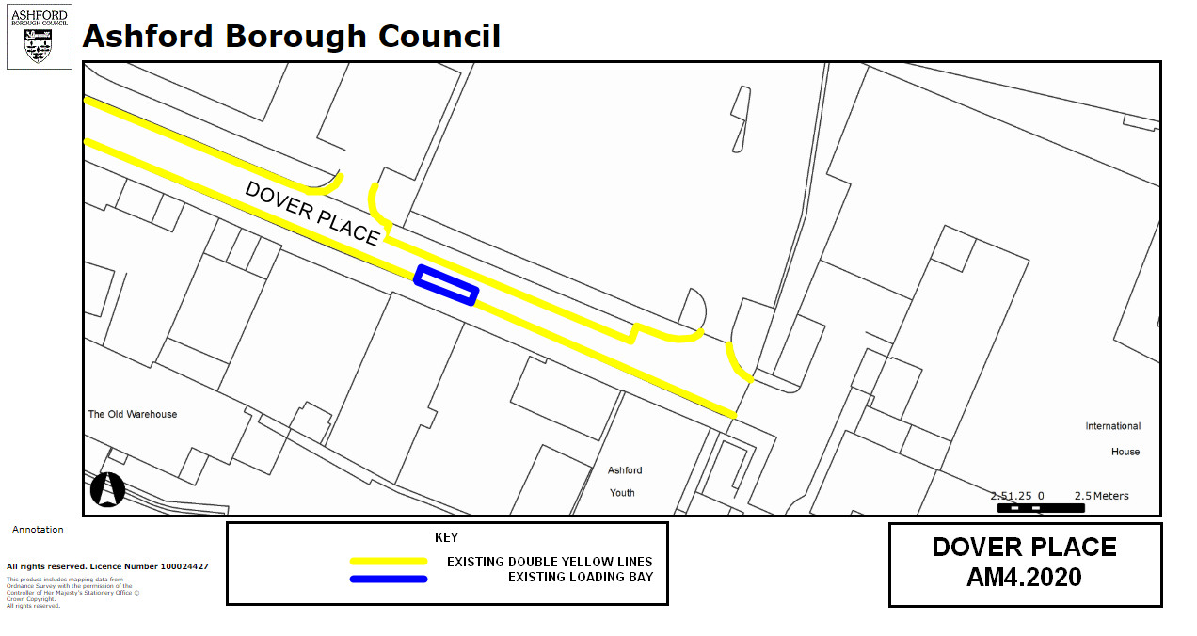

Key:

Existing no waiting at any time restrictions
(Double yellow lines)

Existing Loading Bay

NB No change to restrictions as they appear on the ground

Amendment 4, 2020

Proposed changes
Location:
Dover Place, Ashford

Proposed Order:

The Kent County Council (Various Roads, Borough of Ashford) (Waiting Restrictions and Street Parking Places) Amendment 4 Order 2020

