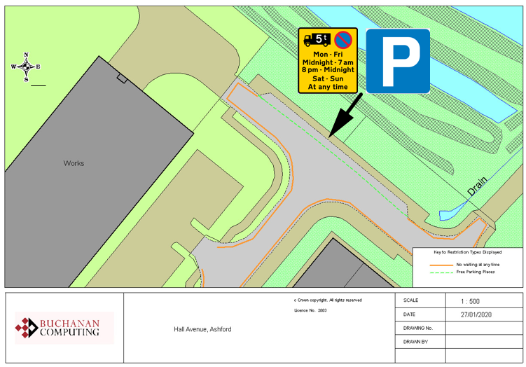

Existing no waiting at any time restrictions

Proposed parking bay

N.B. existing overnight waiting ban (over 5t) will not be affected

Key:
Location:
Hall Avenue, Ashford
Proposed Order:

The Kent County Council (Various Roads, Borough of Ashford) (Waiting Restrictions and Street Parking Places) Amendment 4 Order 2020
Amendment 4 2020

Proposed changes

